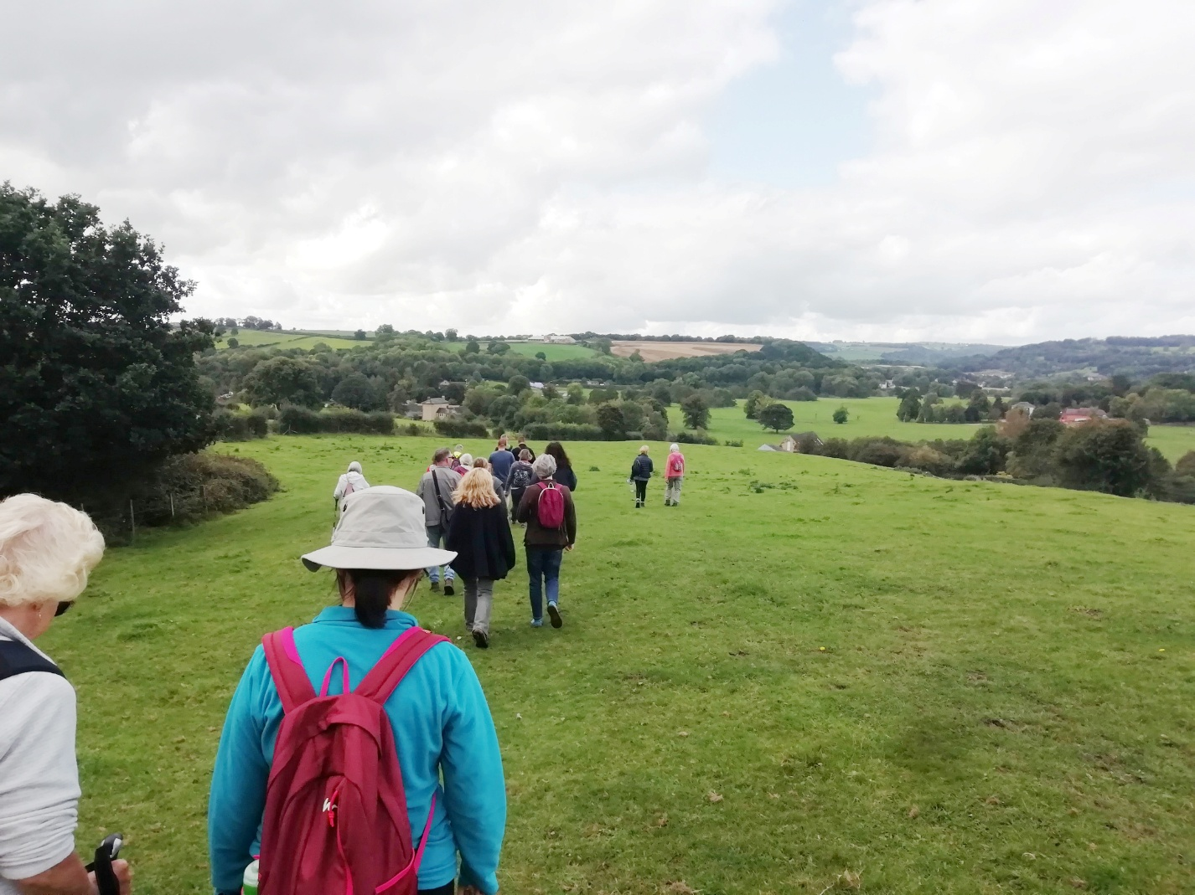

**Annual Walking Festival returns with 24 guided walks**

The annual [Autumn Footprints Walking Festival](https://www.autumnfootprints.co.uk/) is back from 13th until 28th September 2025, offering 24 guided walks that explore the beauty and history of Amber Valley. The event has something for people of all ages and fitness levels, from experienced hikers to families.

Led by knowledgeable local volunteers, the walks take place alongside rivers and canals, open countryside, towns and villages. Participants will learn about the local heritage, natural history and wildlife of each area and get great insights by their enthusiastic guide.

This event is in collaboration with [Amber Valley Borough Council](https://www.ambervalley.gov.uk/) and regional charity [Groundwork Five Counties](https://www.groundwork.org.uk/fivecounties/), and has been a staple in the local calendar since 2002.

Autumn Footprints co-ordinator Marion Farrell from Groundwork says: “Last year we welcomed over 250 people to 16 walks, and we had such great feedback that we have new walk leaders offering more walks this year.

“Derbyshire is a beautiful region with so much history, which our guides are keen to explore with you. You’ll gain a new perspective on the area, meet new people, improve your physical and mental wellbeing, and have a great outing.

“We are always delighted to see the joy people get out of walking, exploring, and learning. Each year we have an influx of new walkers that join familiar faces - some have been coming almost as long as we’ve been holding the Festival, which is amazing!

“Everyone is welcome. We have a variety of walks available, ranging from leisurely strolls suitable for the whole family, to more challenging routes for seasoned adventurers. The walks are of varying lengths and gradient, from one to ten miles.”

People are welcome to join one or multiple events, and booking is essential. Most walks are free, with a small charge for some. To see what’s on offer and book your place, visit the website: [www.autumnfootprints.co.uk](http://www.autumnfootprints.co.uk)

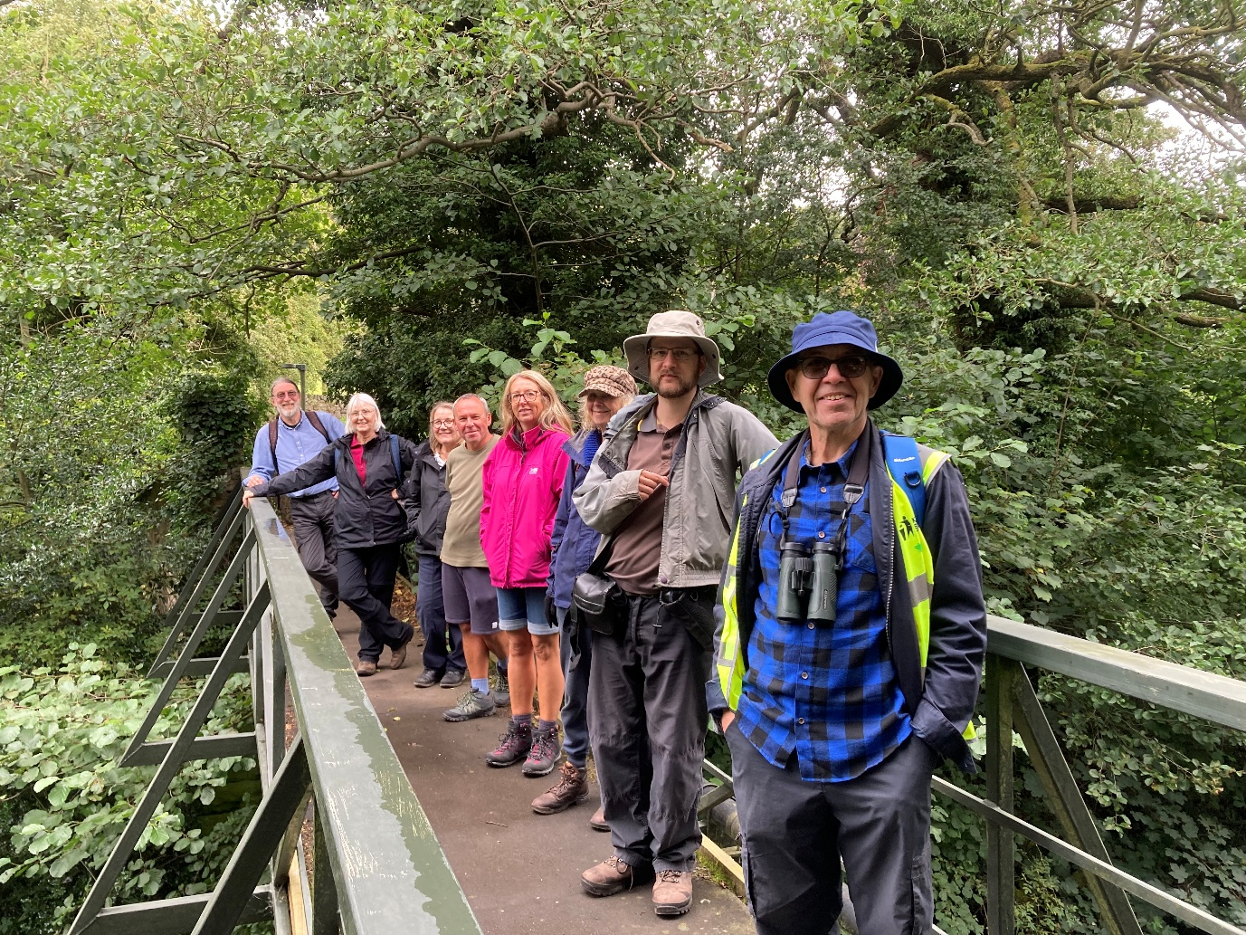

________________________________________________________________________________

**NOTE TO EDITORS**

Further press enquiries

Please contact Marion Farrell at Groundwork. Tel. 07801 122 494. Please take a look at the website for details [**www.autumnfootprints.co.uk**](http://www.autumnfootprints.co.uk)

**Photo opportunities**

Photo opportunities will be available throughout the festival. To arrange, please contact Marion Farrell, at Groundwork Tel 07801 122 494.

**About Autumn Footprints**

‘Autumn Footprints’ is the annual autumn walking festival, held in the Derbyshire borough of Amber Valley. A partnership between Groundwork Five Counties and Amber Valley Borough Council. ‘Autumn Footprints’ provides a varied programme of walking activities, from gentle family rambles to more strenuous hill walks for the more experienced walker.

Amber Valley borough has an extensive range of countryside walks leaflets for self-guided tours, created in partnership with Groundwork.

**Contact information of organisers**

**Groundwork Five Counties**

Tel: 07801 122 494 – Marion Farrell, Walk Festival Co-ordinator (Based in Ripley Town Hall)

Groundwork Five Counties (formerly Groundwork Greater Nottingham) is part of a federation of local Trusts in England, Wales and Northern Ireland each working with their partners in deprived areas to improve the quality of the local environment, the lives of local people and the success of local businesses. Groundwork Five Counties works on community regeneration projects in Derbyshire, Nottinghamshire, Leicestershire, Rutland and Lincolnshire. Groundwork has offices in Nottingham city centre and at Amber Valley Borough Council, Town Hall, Ripley, Derbyshire DE5 3BT.

**Amber Valley Borough Council:**

Tel: 01773 841 485