

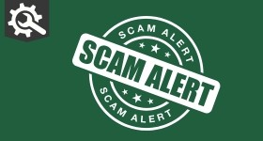

# Fraud Alert: Door to door salesman

We have received several recent reports of rogue door to door salesmen in Derbyshire who sell cleaning goods but then vastly overcharge.

They are particularly targeting elderly and vulnerable people – if you have any older family members, friends or neighbours please check in with them to make them aware of the scam.

Our advice is do not open the door to or engage with anyone trying to sell goods, or to anyone you don’t know or are not expecting.

PC Peter Herrett from our Fraud Unit said: “There is a cross county operation targeting the activities of these criminals to bring them to justice and prevent future victims.

“In the meantime, we’re asking you to share this message far and wide, and if you see any suspicious activity to please report it to us.”

Recent incidents have been reported in Codnor, Draycott and Sandiacre, but there may have been unreported cases across the county.

**Message Sent By** Evie Pugh

(Police, Engagement Officer, Force)

