




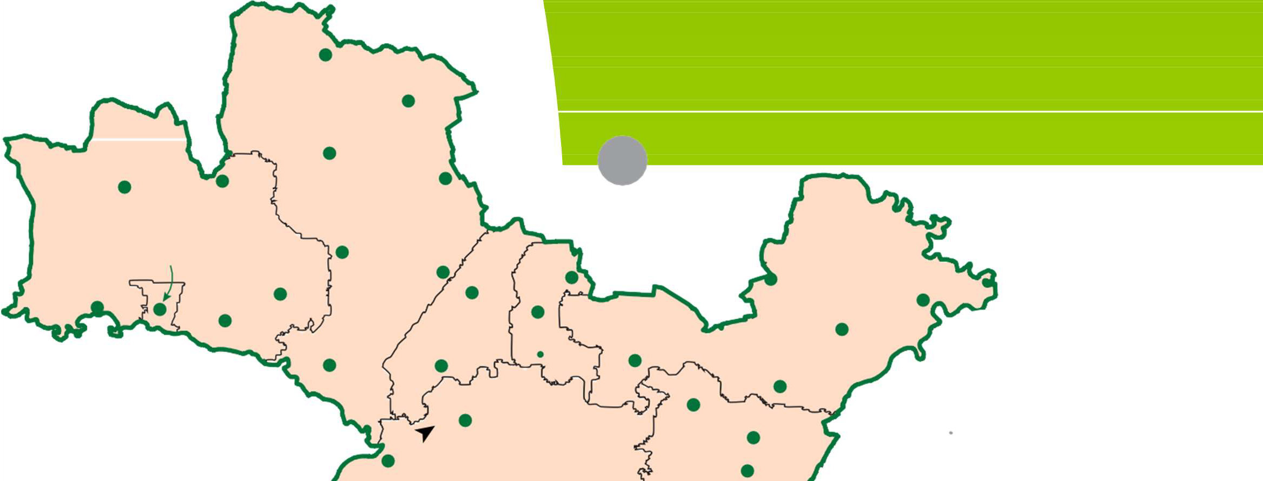
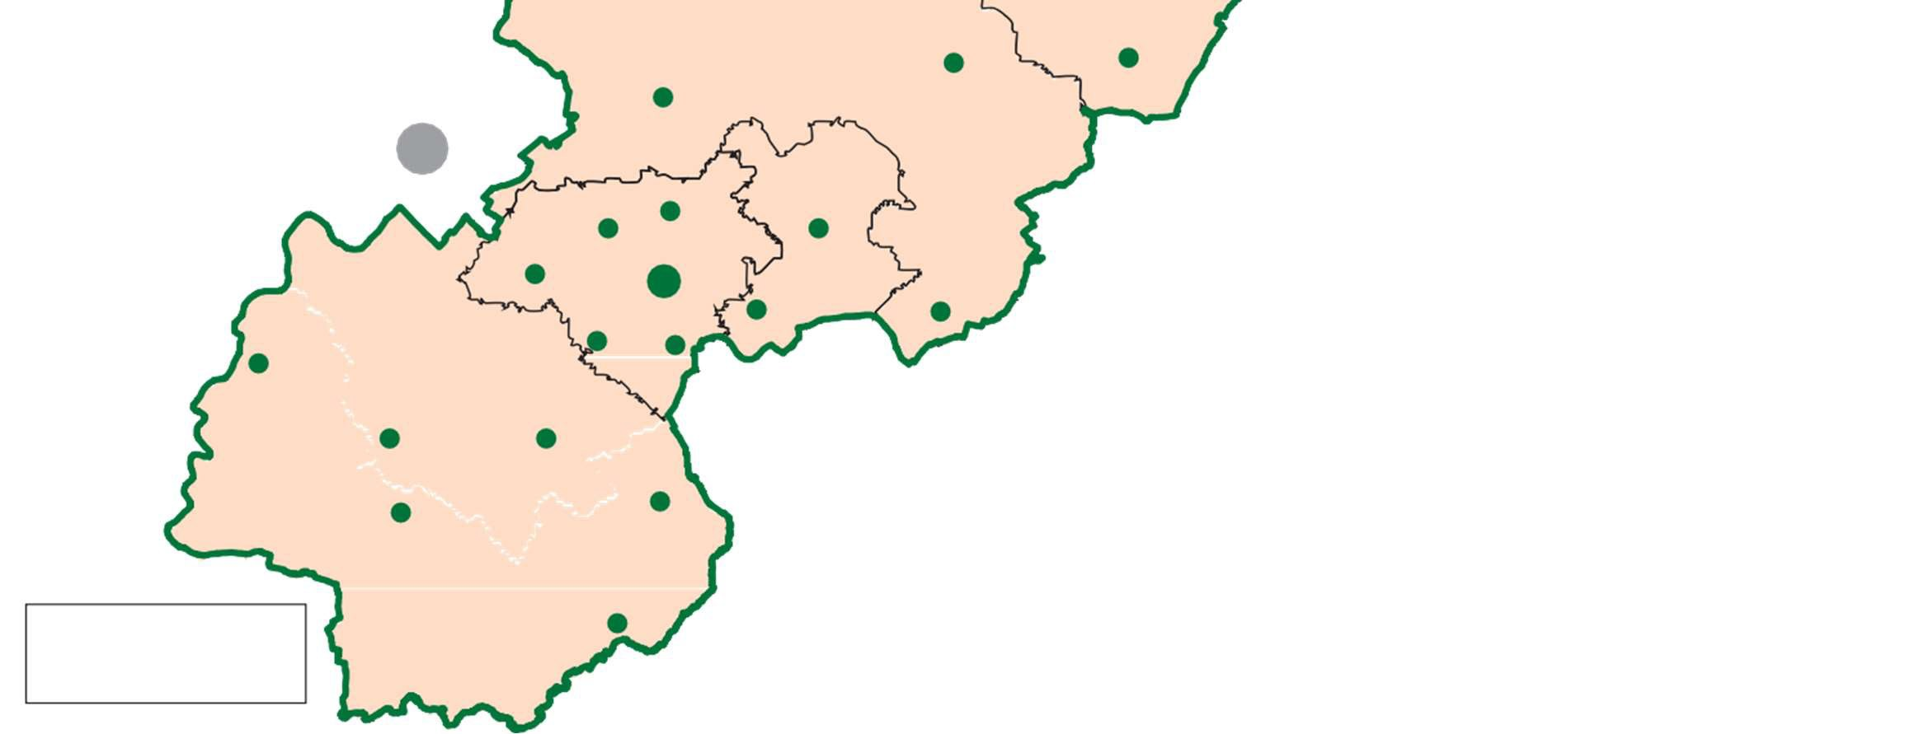


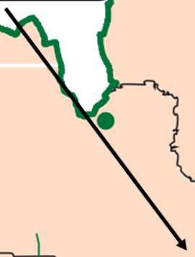




Hilto
South
Derbyshire
District Council
Venue:
Hilton Village Hall
Date: 1
0
th
November
202

6
Time:
pm - 18.45pm
15.30
Church
Broughton
Sutton
on the Hill
Hatton
Lees
Radbourne
Dalbury
Mickleover
Country Park
Etwall
DERBY
Boulton
Scropton
Burnaston
Stenson
Fields
Moor
Shardlow
Marston
on Dove
Egginton
Findern
Willington
Stenson
Twyford
Barrow
on Trent
Aston on Trent
Weston on Trent
Repton
Stanton
by Bridge
Kings
Newton
BURTON
ON TRENT
Newton Solney
Bretby
Ticknall
Melbourne
Woodhouses
Newhall
Midway
Hartshorne
Stanton
Swadlincote
Castle Church
Woodville
Smisby
Walton on Trent
Rosliston
Coton
in the Elms
Gresley Gresley
Overseal
Crown copyright and database
rights (2024) Ordnance Survey
AC0000814783
Netherseal

South Derbyshire District
Council Local Plan
Consultation Events
Further information can be found on our web site at:
www.southderbyshire.gov.uk/
part2reg19
or by scanning the QR code
Linton
Venue:
Repton Village Hall
Date: 5th November
202

6
Time:
16.
00
pm - 18.45pm
Venue:
Sharpes Pottery Museum
glaze room), Swadlincote
(

Date: 13th November 2027
Ti
me:
pm - 18.45pm
15.30
Venue:
Frank Wickham Hall,
Etwall

Date:
4
th
November
202

6
Time:
pm - 17.45pm
15.30
Consultation closes 5pm 30th November 2026
Venue:
Drakelow Park Flying
High Academy

Date: 11th November 2026
Ti
me:
1
6
.
0
0
pm - 18.45pm
Drakelow
The District Council is holding a
series of 'drop in events
'
during
November to discuss the
Publication
Version
Local Plan
Part 2 Review.

